**NAME – KHUSHI PANWAR, khushipanwar26@gmail.com**

**ROLL NO – 2021334**

**C++ PRACTICAL ASSIGNMENT – 13 JAN 2022**

1. **Write a program that performs Matrix addition, subtraction using 2D arrays:**

#include <iostream>

#include <iomanip>

using namespace std;

int inputMatrix(int m[][3]){

    for (int i=0; i<3; i++){

        cout<<"Enter the elements for row "<<i+1<<" : ";

        for (int j=0; j<3; j++)

        cin>>m[i][j];

    }

}

int addition(int m1[][3], int m2[][3], int sum[][3]){

    for (int i=0; i<3; i++){

        for (int j=0; j<3; j++)

            sum[i][j]=m1[i][j]+m2[i][j];

    }

}

int subtraction(int m1[][3], int m2[][3], int difference[][3]){

    for (int i=0; i<3; i++){

        for (int j=0; j<3; j++)

            difference[i][j]=m1[i][j]-m2[i][j];

    }

}

int displayMatrix(int m[][3]){

    cout<<endl<<"============================="<<endl<<endl;

    for (int i=0; i<3; i++){

        for (int j=0; j<3; j++)

        cout<<setw(5)<<m[i][j];

        cout<<endl;

    }

    cout<<endl<<"============================="<<endl<<endl;

}

int main(){

    cout<<"\t * MATRIX ADDITION AND SUBTRACTION (3x3) *" <<endl<<endl;

    cout<<"========================"<<endl;

    cout<<"\t SELECT : "<<endl<<endl;

    cout<<" 1. MATRIX ADDITION "<<endl;

    cout<<" 2. MATRIX SUBTRACTION "<<endl;

    cout<<"========================"<<endl;

    int choice, size;

    int matrix1[3][3];

    int matrix2[3][3];

    int difference[3][3];

    int sum[3][3];

    char ch='y';

    while (ch=='y'){

        cout<<"What operation do you want to perform (1 or 2)?? ";

        cin>>choice;

        cout<<endl<<"\t * ENTER ELEMENTS FOR MATRIX 1 *"<<endl;

        inputMatrix(matrix1);

        cout<<endl<<"\t * ENTER ELEMENTS FOR MATRIX 2 *"<<endl;

        inputMatrix(matrix2);

    switch(choice){

        case 1: addition(matrix1, matrix2, sum);

                cout<<endl<<setw(20)<<"* SUM OF MATRIX *";

                displayMatrix(sum);

                break;

        case 2: subtraction(matrix1, matrix2, difference);

                cout<<endl<<setw(20)<<" * DIFFERENCE OF MATRIX *";

                displayMatrix(difference);

                break;

        default : cout<<"INVALID CHOICE! "<<endl;

    }

    cout<<"Do you want to continue(y/n)? ";

    cin>>ch;

    cout<<endl;

    }

    return 0;

}

**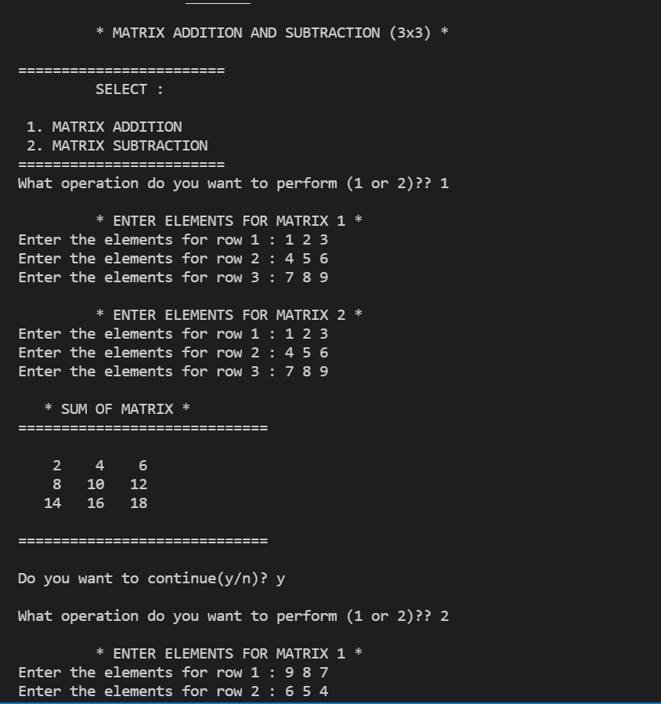  
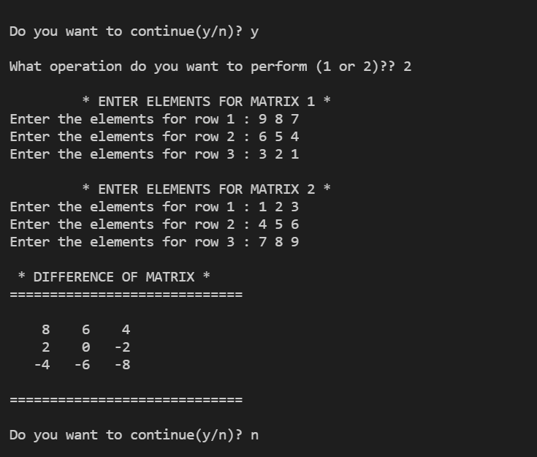**

1. **Write a program that finds GCD of two numbers:**

#include <iostream>

using namespace std;

int gcd(int a, int b){

    while(a!=b){

        if (a>b)       a-=b;

        else        b-=a;

    }

        return a;

}

int main(){

    int a,b;

    cout<<endl;

    cout<<setw(40)<<"* CALCULATE GRATEST COMMON DIVISOR OF NUMBERS*"<<endl<<endl;

    cout<<"-> Enter first number : ";

    cin>>a;

    cout<<"-> Enter second number : ";

    cin>>b;

    cout<<endl<<"The Greatest Common divisor of "<<a<<" and "<<b<<" is : "<<gcd(a,b);

    return 0;

}

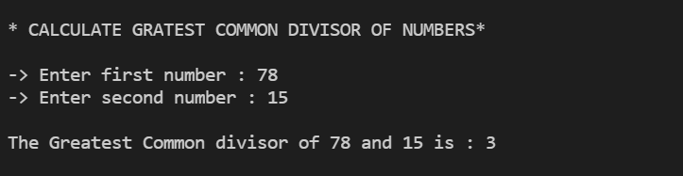

1. **Write a program that merges two ordered/sorted arrays:**
2. **Write a program that performs binary search:**